Chapter 14, Problem 84.

Obtain the frequency response of the circuit in Fig. 14.101 using PSpice.

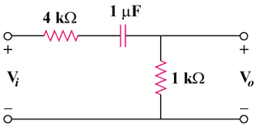

Figure 14.101
For Prob. 14.84.

